Buckley Runners

Coaching framework Discussion Document Summary)

Twelve months ago, we adopted a new approach to managing club sessions, setting up three groups and a week by week schedule for each group. Each group nominally had a run leader who took responsibility for the group. A small number of runners undertook Running for Fitness Leader course. We have a degree of organisation but planning and group allocation is still informal.
This document is a summary of a lengthy report. It aims to set out the issues and seek to move the club and its members forwards.
Aim
To develop a coaching process that consistently and continually delivers improved performance for all club members based on their needs
Objectives:
- To introduce a coaching process framework that will deliver continual and consistent performance improvement to club members based on their needs
- To use coaching to increase an individual’s level of performance from current levels identified through annual goal setting.
- To establish individual personal development plans for members so they can plan their progress and have support and commitment to their longer-term development.
- To focus on annual goals for club team events and provide prioritised specific coaching.
- To provide an inclusive training and coaching environment which address the wide range of abilities and personal motivations
Observations and comment on the current coaching system:
- Each of our current coaching groups appears to operate differently and independent of each
- There are no overall year plans or goals for coaching
- Progression between coaching groups is not generally encouraged or planned
- We have talented athletes within each group who could improve even further given specific direction.
Framework proposal
The coaching structure would be:
- Overseen by a Chief Coach
- Based on 4 groups, each overseen by a Group coach supported by a number of run leaders.
- Require run leaders to be responsible for leading the session and ensuring the health, safety and welfare of the runners in the group during the run.
In order to improve inclusion and to accept that not all runners aspire to being a part of the highest group, the groups will be named Red, Blue and Yellow and Green.
- Red group would be similar to the existing top group,
- Blue group would be similar to the existing Middle group whilst
- Yellow group would equate to the current beginners group. The final group
- Green would be a new group and would follow a couch to 5K approach
Each group will have specific race based performances criteria for entry and progression within the groups. Runners are allowed to drop to a lower group if coming back from injury or other lay-off. They will only be allowed to move to a higher group on achieving the required time. Upward transition would occur at the start of a new training block.
Training Programmes
Group coaches will develop 10 or 12 week progressive programmes covering distance, pace and routes. The first week of each block would include a progress check in the form of an appropriate distance time trial in order to gauge progress of each individual athlete. Programmes will be agreed with the Chief coach and be published in advance. They will form the basis of all training.
Personal development
Currently there is no personal development or individual training plans offered to runners on a consistent basis. Whilst it is accepted that many runners have the knowledge and experience to develop their own training, some runners will undoubtedly look to the club for guidance either on a long-term development plan or else for a specific race. Currently runners ask anyone at the club or on social media. This solicits many often-conflicting suggestions which may not be appropriate to that individual runner.
As part of the coaching process, any runner who requires help with developing a training plan for a specific race or for general improvement should in the first approach his/her group coach who would develop a plan based upon the runner’s goals and needs.
Next steps
Clearly it will not be possible to transition to this framework instantly however there should be an intent to transition to this over the next few months. In order for this to happen the following needs to be undertaken
- Identify and recruit Chief coach, Group coaches, Run leaders (at least 2 per group)
- Facilitate attendance on appropriate Coaching and run leader courses
- Identify which groups existing runners will be allocated to
- Communicate coaching framework to all members and group allocations
- Develop first 10 or 12-week block training plan
- Commence first training block for all groups
Appendix 1 - Proposed Club Coaching Structure

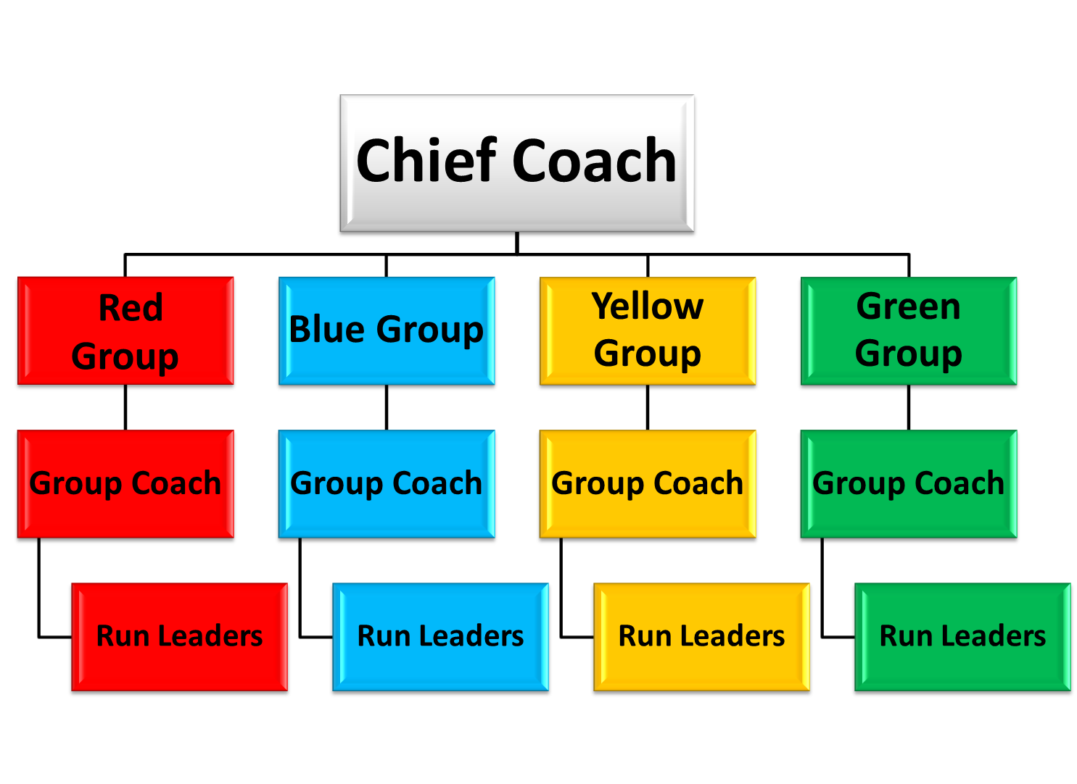
The suggested transition criteria for each group is:

Group | 5K Time | 10K Time | Half Marathon
Red | <16 mins-22 mins | <33 mins-44 mins | <1.09-1.34
Blue | 21 mins-28 Mins | 42 mins-55 mins | 1.29-1.55
Yellow | >27 mins | >54 mins | >1.50
Green | New comers to running no competitive experience

Roles and Responsibilities

All club training would be overseen by a Chief coach who would be responsible for overseeing and approving the training plans for the 4 groups and would be the overall arbitrator for coaching related activities within the club. The club coach would be responsible for approving all club training activities. This will ensure that there is a consistent one club approach to training.

The responsibilities of each of the roles is as follows:

Chief Coach

- Oversee all club training
- Approve group training programmes
- Set goals and objectives for the year
- Agree approved club training sessions

Group Coach
- Oversee training for one group
- Develop training programmes for group
- Develop personal training plans as required for individual group members

Run Leader
- Lead sessions at club training
- Act as run monitor to ensure all runners are with the group and have no health, safety or welfare issues
- Act as tail runner for group

